Pinhole lamp

Kay’s teacher places a bright lamp in front of a very small hole.

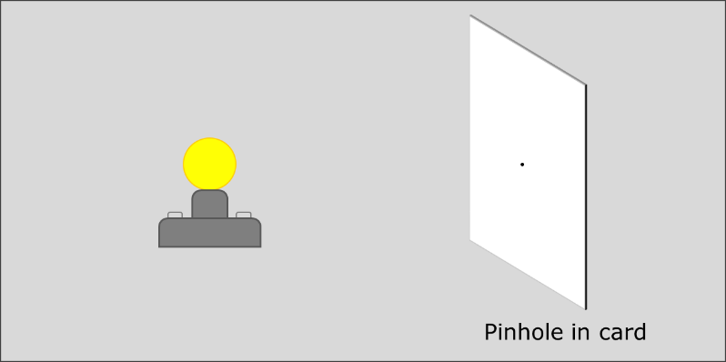

Which diagram best shows how light passes through the pinhole?

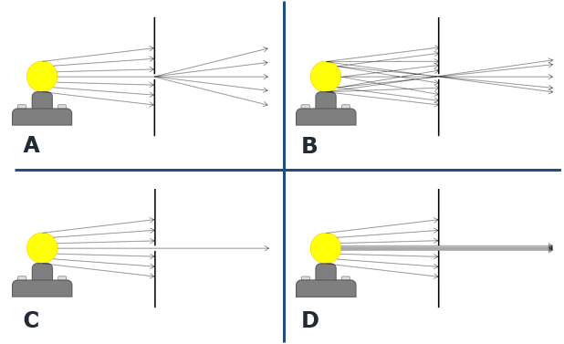
Physics > Big idea PSL: Sound, light and waves > Topic PSL3: Making images > Key concept PSL3.1: The ray model of light to explain images
Diagnostic question
Pinhole lamp

Overview
Learning focus: | Only some light rays from each point of an illuminated object can pass through a pinhole, hitting a screen at distinct points to make an inverted image.
Observable learning outcome: | Describe how light rays pass through a pinhole.
Question type: | Simple multiple choice
Key words: | Light ray, pinhole

What does the research say?
In order to explain image formation students need to understand that a light is emitted in all directions from each point on the source (Rice and Feher, 1987; Dedes and Kanstantinos, 2007; Galili and Hazan, 2000; Andreou and Raftopoulos, 2011). A suitable conceptual progression of how an image in a pinhole camera forms might start with the idea that rays represent the direction light travels in; use rays to show light moving from a luminous or illuminated object towards a pinhole; and finish with one ray from each point, out of infinitely many, passing through the pinhole and contributing to the formation of an image (Andreou and Raftopoulos, 2011).
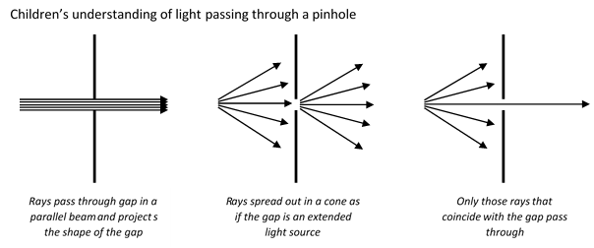
Without the correct understanding of light emission from extended sources students make mistakes explaining how light passes through a pinhole. Galili and Hazan (2000) found over a third of students aged 14-16 thought light passed through a pinhole in a parallel beam. A further third thought that light spread out after the pinhole as if the hole was an extended source of light, and after instruction this increased to more than half.
Ways to use this question
Students should complete the confidence grid individually. This could be a pencil and paper exercise, or you could use an electronic ‘voting system’ or mini white boards and the PowerPoint presentation.
If there is a range of answers, you may choose to respond through structured class discussion. Ask one student to explain why they gave the answer they did; ask another student to explain why they agree with them; ask another to explain why they disagree, and so on. This sort of discussion gives students the opportunity to explore their thinking and for you to really understand their learning needs.

Differentiation
You may choose to read the questions to the class, so that everyone can focus on the science. In some situations it may be more appropriate for a teaching assistant to read for one or two students.
Expected answers
Answer B is correct
How to respond - what next?
Answer B shows light moving in several directions from each point of the bulb. The light that is incident on the slit moves through in a straight line, the light that hits the screen is blocked (and reflected).
Answers C and D show variations of this, except that in each of these answers only one ray of light is shown to be emitted from each point on the extended light source. This misunderstanding often increases with teaching and needs to be challenged. Answer D is perhaps closer to the correct answer than answer C because there are very many rays along which light is emitted from a lamp.
Answer A shows the pinhole acting as if it were itself a light source. It is a common misunderstanding because the rays after the slit look the same as the correct answer. What is missing is a mechanism to cause the spreading out of the light.
If students have misunderstandings about how light from a lamp passes through a small hole, it can be helpful to demonstrate what happens when a bright bulb is placed in front of a small hole. It can be shown that light spreads out in a cone to produce a circle of light on a screen. This can be shown more clearly in two dimensions with a ray lamp and slit (without a collimating lens).
To distinguish between answers A and B a laser could be used to illustrate that the movement of light represented by a single ray passing through a pinhole is in a straight line and does not bend. The method for doing this is described, with health and safety advice, in the BEST diagnostic question: Pinhole laser.
The following BEST ‘response activity’ could be used to facilitate paired or small group discussions about how light passes through a pinhole, which encourage social construction of new ideas through dialogue:
- Response activity: Light through a hole
Acknowledgments
Developed by Peter Fairhurst (UYSEG).
Images: Peter Fairhurst (UYSEG).
References
Andreou, C. and Raftopoulos, A. (2011). Lessons from the history of the concept of the ray for teaching geometric optics. Science and Education, 20, 1007-1037.
Dedes, C. and Kanstantinos, R. (2007). Teaching image formation by extended light sources: the use of a model derived from the history of science. Research in Science Education, 39, 57-73.
Galili, I. and Hazan, A. (2000). Learners' knowledge in optics: interpretation, structure and analysis. International Journal of Science Education, 22(1), 57-88.
Rice, K. and Feher, E. (1987). Pinholes and images: childres's conceptions of light and vision. Science Education, 71(4), 629-639.

